

cs-465-fullstack-MEAN

CS 465 Project Software Design Document
Version 1.2

Table of Contents

CS 465 Project Software Design Document 1
Table of Contents 2
Document Revision History 2
Instructions 2
Executive Summary 3
Design Constraints 3
System Architecture View 3
Component Diagram 3
Sequence Diagram 4
Class Diagram 4
API Endpoints 4
The User Interface 4

Document Revision History

Version | Date | Author | Comments
1.2 | 12/12/25 | Matthew Dunfee | Week 7

Executive Summary

In order to achieve the client application specifications, we are going to be using a hybrid architecture. Using the MEAN stack, we will use an Express server to connect to a MongoDB backend, which will be consumed by two different front-end interfaces. The client-side application will be hosted on Express as dynamic HTML renderings. The admin dashboard will be propped up with Angular.

Design Constraints

The constraints around this project are common functional and commercial constraints. The project is time-bound. It needs to be done in 5 weeks with a burndown chart that must be followed (weekly assignments). It also has functional restrictions, like speed of use for clients, as well as security restrictions for the admin panel. It is expected that this panel or dashboard be built as an SPA. Data must be persistent. It is expected that the MEAN tech-stack will be used.

System Architecture View

Component Diagram

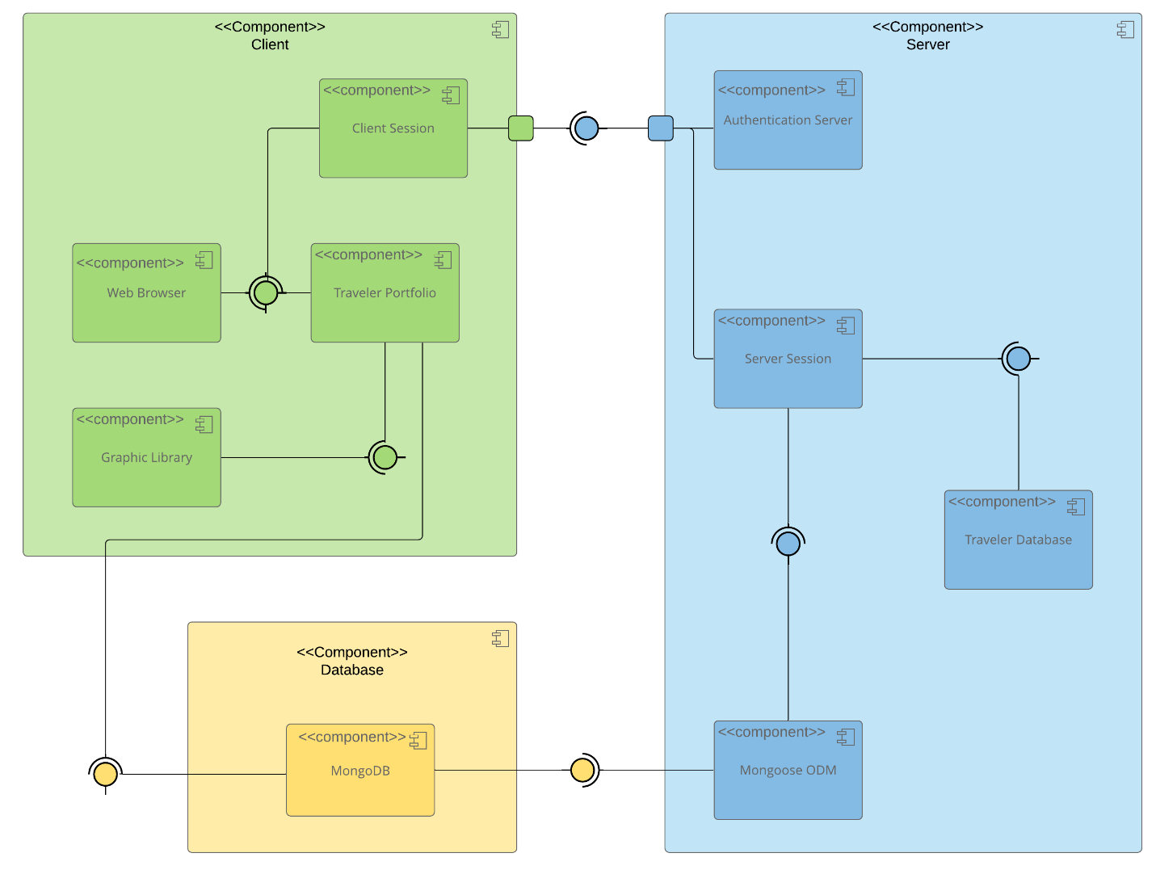
While the application has a client, server, and database, it is certainly not a traditional three-tier architecture. That is because its communication is not linear. The Component Database rests in the middle of the client and server. Both consume it, and it consumes neither. The client also consumes the server, but the server only consumes the database. Within the client, there are four major components: a graphic library, a template for injecting database information, a web interface, and a component for managing session state. The server has four components as well: One for authentication, authorization, an internal database, and an ODM for communicating with the external database.

Sequence Diagram

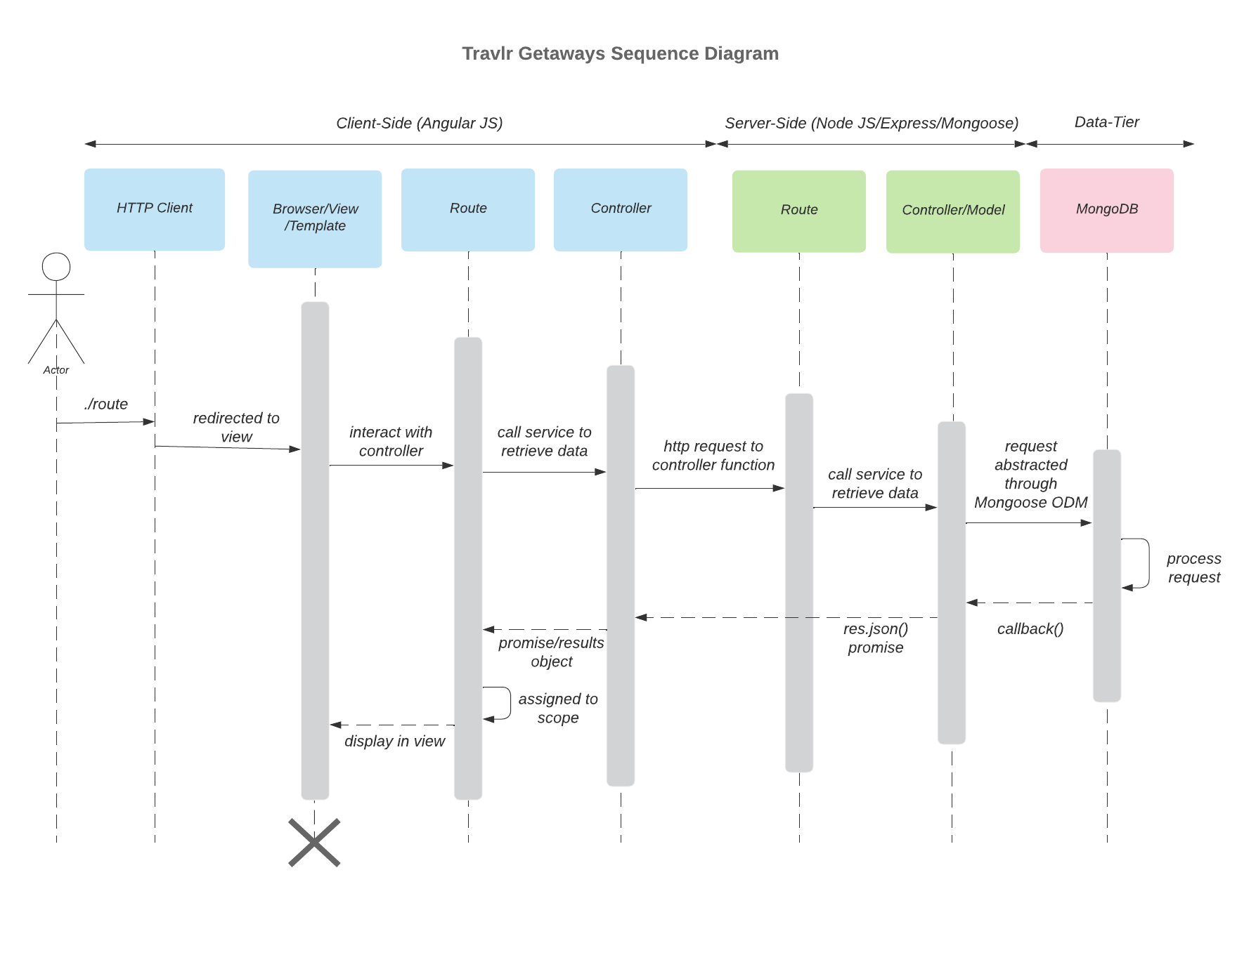

The Client Calls the app.js file via http//:domain/travel. The call is redirected from app.js with express isntance.Use function to call route travel.js. That calls travel.js Controller with makes a http call to the api/travel. That is caught by the index.js route file (might renamed) which then calls the travel api controller. That calls the database via mongoose. Once returned is passed back up to the frontend controller. It then passes the data to handlebars and is displayed.

- Hits Browser (Dom )
- Backend (App.js)
- Front end Route (Travel.js)
- Frontend Controller (Travel.js)
- Backend Route (index.js)
- Backend ControllerMogoose (Travel.js)
- Backend MongoDB (localhost > cs465-fullstack-mean)
- Backend ControllerMogoose (Travel.js)
- Front end Controller (Travel.js)
- Front end View/handlebars (Travel.hbr)

Class Diagram

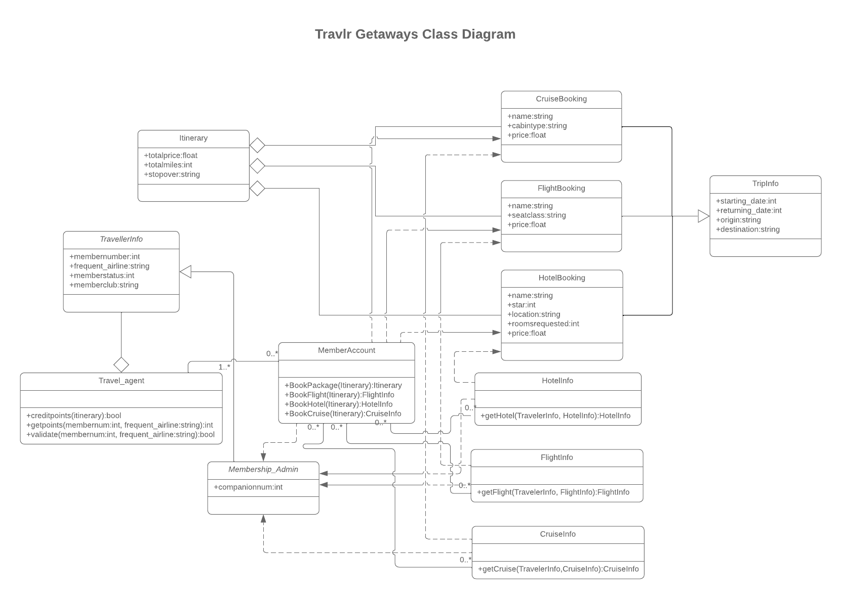

- The Itinerary is an aggregate of flight, hotel, and cruise bookings. All of which have TripInfo inheritance. The three bookings are one-way associations of respective Info classes. Those three Info classes have one-way association with the Membership_Admin class.
- Member Account is associated with flight, hotel, and cruise info classes. It is also associated with Travel Agent. Member Account has a one-way association of the flight, hotel, and cruise bookings classes. It also has one-way association with Membership_Admin.

- TravellerInfo is an aggregate of Travel_Agent. TravellerInfo inherits from Membership_Admin.

API Endpoints

RESTful endpoints are designed to enable the application to participate in a larger ecosystem.

Method | Purpose | URL | Notes
GET | Retrieve list of travel locations | /api/travel | Returns all active locations
POST | Add travel location | /api/travel | Adds a location
GET | Retrieve single travel location | /api/travel/:code | Returns single thing instance, identified by the code ID passed on the request URL
PUT | Updates a single travel location | /api/travel/:code | Must pass code ID
POST | Adds new Authorized user | /api/register | Requires Username, email, and password
POST | Authenticates user. | /api/login | Requires Username, email, and password

The User Interface

The Admin base page:
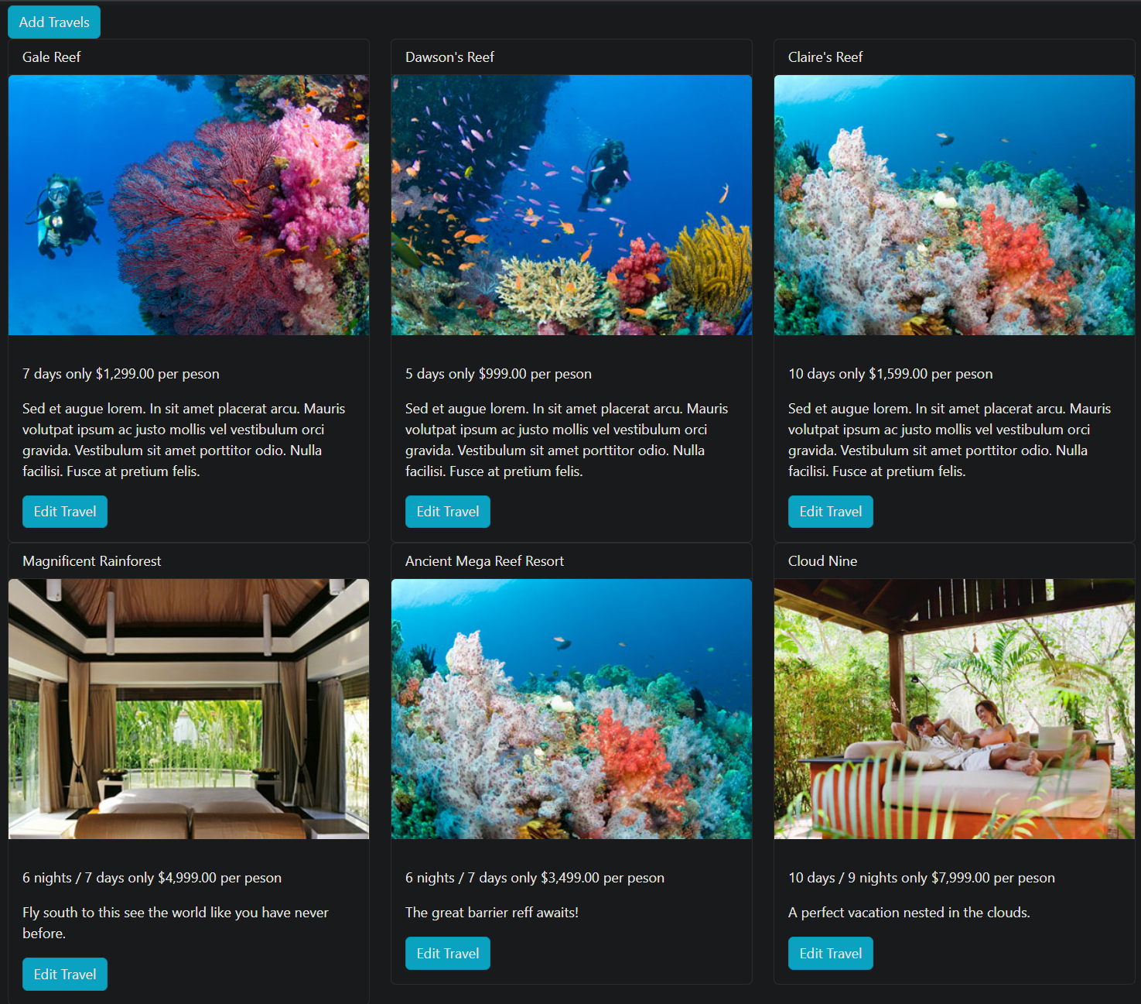

The SPA allows the authenticated users to add or update trips!

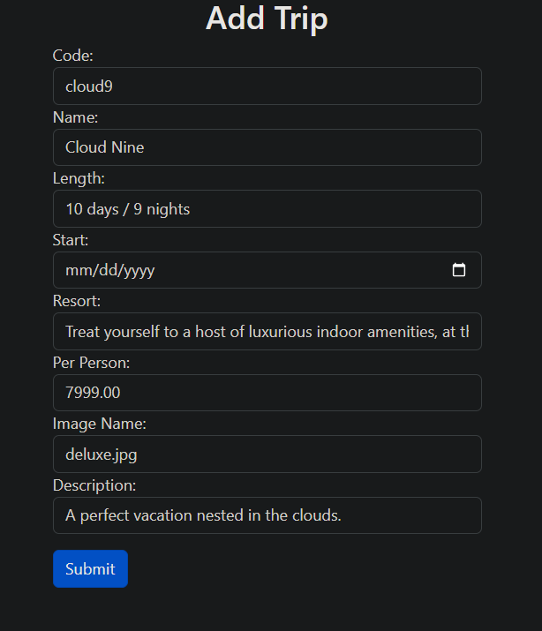

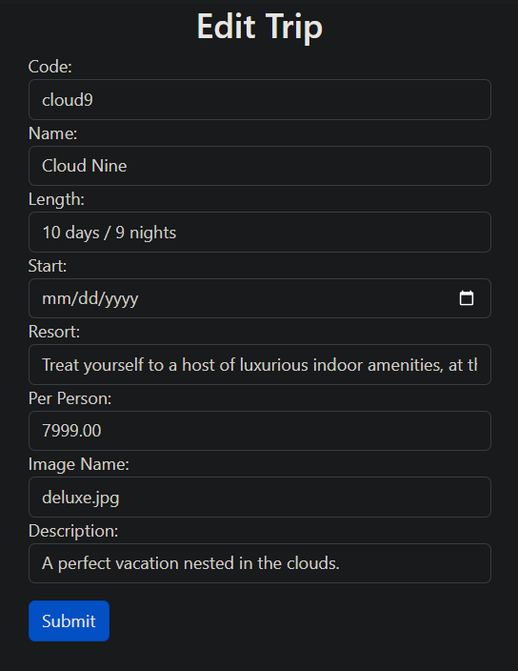

Before: After
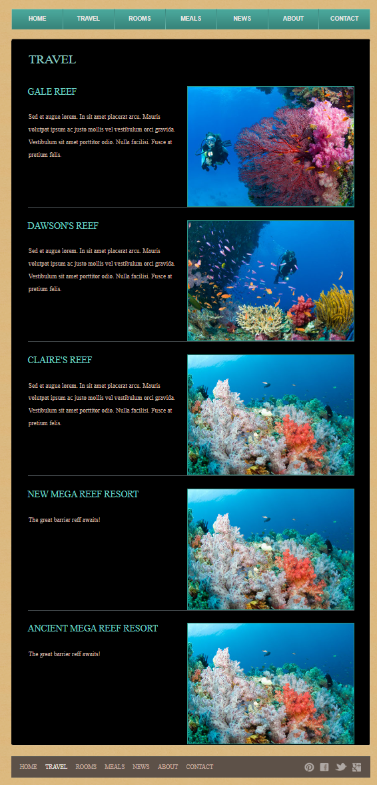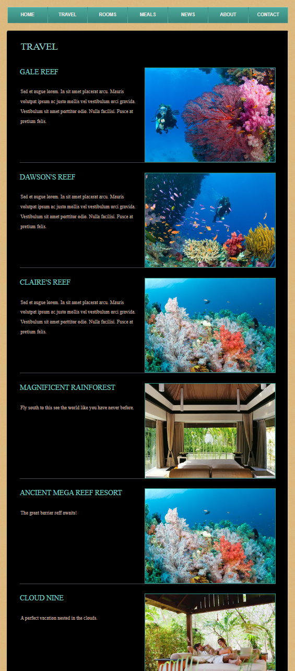

Angular is rich in structure. From its CLI to the components and services that build the site. It allows for inherent abstraction and excels at building complex models into modular code. Because of this, it is well-suited to working with API’s with defined classes and entities. Its HTTP modules allow it a seamless connection and testing. For this project, manual testing through Postman was used, but the framework automatically generates .spec.ts files that are perfect for testing modules. In summary, Angular is a feature-rich framework and is perfect for building robust applications.

